Competency Check: Tying Up horses
Employee name:_________________________________________________ Date:____________
Context: | This Competency Checklist covers the process of tying up a horse and covers the following performance criteria:  - The quick release knot  - Tethering to “Pull-back” lines  - Tethering to bailing twine  Applicants must have successfully demonstrated the ability to perform the performance criteria in order to be deemed competent to tie up a horse.
Tethering a horse
Task | Performance Criteria | Attempt date
1. The quick release knot | A quick release knot is used to ensure in an emergency or if the horse panics you can safely untie him and take control. There are a number of ways to tie a quick release knot but the quickest and easiest is as follows:  - Pass the running end (the end not connected to the snap) of the rope through the baling twine.  - Make a circle around the tie rope.  - Push the doubled end of the rope through the circle.  - Snug up the knot. To release the rope, pull on the long end.  - To keep the horse from untying himself by pulling on the end of the rope, tuck it through the big loop in the knot.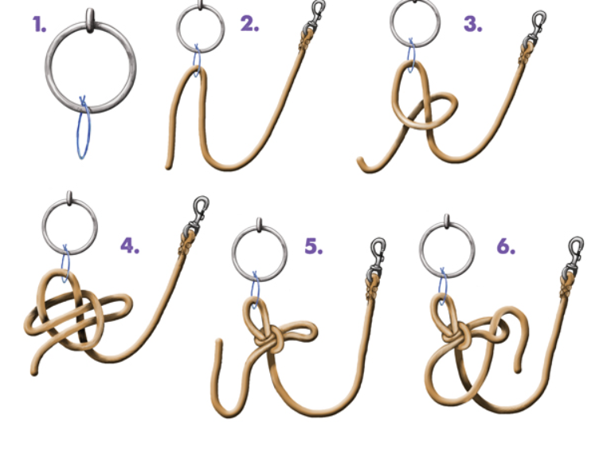
2: Tethering to “Pull-back” lines | - Ensure the “pull-back” line is secured in the carabiner prior to attaching the horse.  - Shorten the pull-back line until it is approximately 60cm long.  - Clip the horse to the pull-back line and remove the lead rope.  - Place the lead rope over the hitching rail for later use.
3: Tethering to the bailing twine | - Stand on the nearside of the horse and approach the tethering point.  - Ensure adequate space for your horse  - Use a quick-release knot  - Check your 60cm or forearms’ length of lead rope from the horse’s halter to the hitching rail.  - Don’t leave the horse unsupervised whilst tethered.

Assessor name: ________________________________________________ Date: ________________
Assessor signature: _____________________________________________
Employee signature: _____________________________________________ Date: _______________

