Competency Check: Handling the Hooves
Employee name:_________________________________________________ Date:____________
Context: | This Competency Checklist covers the process of handling and picking out hooves and covers the following performance criteria:  - Preparing to pick up feet  - Procedure for Front feet  - Procedure for Back feet  - Identify parts of the hoof  Applicants must have successfully demonstrated the ability to perform the performance criteria in order to be deemed competent to groom horses.
Task | Performance Criteria | Competent (C) Not Yet Competent (NYC)
1: Preparing to pick up hooves | - Equipment is prepared; hoof pick, antifungal spray etc  - Horse is held by another person or tied up using appropriate method.  - Outline why we clean out the hooves and what we are checking for.
2: Picking up Hooves- Procedure for Front feet | - Stand at horse’s shoulder facing the horses rump, slide inside hand down the back of the horse’s leg and foot and encourage horse to pick up his foot by saying ‘up’ and lifting from the fetlock. DO NOT CLICK AT THE HORSE AS THIS ENCOURAGES THEM TO MOVE AROUND. You may need to apply gentle pressure with your shoulder to move his body weight off the foot you are trying to pick up.  - When foot is lifted catch the toe with your outside hand and settle the hoof into your inside hand. The outside hand is now free to pick the dirt/rocks from the sole of the hoof and around the frog. Start from the sides of the frog and move towards the toe. Always pick out from the frog to the toe and not the other way around incase the hoof pick slips and damages the frog which is soft and can be damaged by sharp objects.  - Once foot is fully cleaned place horses hoof on the ground.
3: Picking up Hooves- Procedure for Back feet | - Standing at the horse’s hip, facing the rear of horse, run your inside hand down from the point of hip, down the back of the horse’s leg and around to the inside of the fetlock. Encourage horse to pick up his foot by saying ‘up’ and lifting from the fetlock. You may apply gentle pressure with your shoulder to move his body weight off the foot you are trying to pick up.  - Once the horse picks up his hoof, catch the toe with the outside hand and settle it into your inside hand cupped around the hoof. Allow a few seconds for the horse to relax.  - When the horse has relaxed and with the horse’s foot still in hand, step through with your inside leg towards the horses rump, positioning horse’s leg on your leg, the hoof can rest supported in handlers lap or be held, with point of hock underneath inside armpit.  - Hoof is cleaned and handler steps back towards the horse’s head with inside leg while at the same time, placing the hoof back down on the ground.  - Picking hooves takes practice to get the flow of movement, if you are unsure or horse is being resistant, always ask for assistance from any of the adult staff.
4: Parts of the Hoof | - Identify parts of the horse and which parts are sensitive.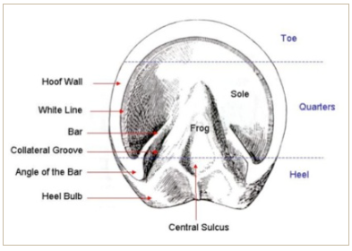  Source: Hoof Anatomy – A Beginner’s Guide – The Equine Podiatry Association

Assessor name: ________________________________________________ Date: ________________
Assessor signature: _____________________________________________
Employee signature: ____________________________________________ Date: ________________

Competent Not Yet Competent

