Competency Check: Saddling horses
Employee name:_________________________________________________ Date:____________
Context: | This Competency Checklist covers the process of saddling a horse and covers the following performance criteria:  - Preparing to saddle  - Checking the saddle  - Saddle cloths  - Saddling  - Girth  - Tightening the Girth  - Parts of the Saddle  Applicants must have successfully demonstrated the ability to perform the performance criteria in order to be deemed competent to saddle horses.
Task | Performance Criteria | Competent (C) Not Yet Competent (NYC)
1: Preparing to saddle | - Selects correct saddle for horse  - Checks the saddle for wear and tear and makes sure it’s ready for use with the correct girth and stirrups attached.  - Selects an appropriate fluffy riser (if required) and saddle cloth for the horse and if unsure check with an adult staff member  - Places the saddle over the tie up rail until required for saddling up, in a safe place out of reach of horses
2: Checking the condition of the horse | - Run you hand over where the saddle and girth is to sit and check it is clean and smooth  - Report any indications of pain or discomfort from the horse to an adult staff member  - If unclean, groom thoroughly to remove dirt so the horse does not develop saddle sores
3: Saddle cloths | - Check the saddle cloth for dirt or sweat  - Place the saddle cloth on the horses wither, slightly forward of where it will eventually sit (just behind the shoulder blade) once done up.
4: Saddling | - Pick up the saddle and ensure the girth remains looped over the saddle seat  - Lift the saddle up with both hands gently lowering it down onto the horses back onto the saddle cloth  - Smooth the saddle and the cloth backward with the lay of the hair into position just behind the shoulder blade  - Pull the saddle cloths up into the channel of the saddle at the pommel to make sure they do not put any pressure on the horses wither or back. There must always be clearance between the wither and saddle pad even when the rider is on board.  - Make sure there is clear space on the cloths at the front and the back of the saddle so that the saddle is not sitting on the edges of the cloths.
5: Girth | - Move safely around to the off side of the horse, lower the girth down so that it hangs freely,  - check the positioning of the saddle cloths and the flaps of the saddle to ensure they are sitting smoothly on the horses side  - Return to the near side of the horse, run your hand over the girth area of the horse so he knows what you are about to do and reach through and take hold of the girth  - Bring the girth buckles up to the girth points of the saddle and loosely buckle the girth into place  - Girth buckles are always closed on either the first and second or first and third girth straps. They are never secured on the second and third girth straps.  - Only tighten the girth enough to keep the saddle in place until the rider is ready to mount. Always ask the coach to check the horses girth before the rider mounts.  - Check the lay of the saddle cloths and the fit of the saddle and report any issues identified
6: Tighten girth | - Once the horse is ready to be ridden, walk the horse to the arena and around the arena for five minutes to warm up  - Check and tighten the girth enough so that the saddle doesn’t slip went a person is mounted, but not so tight that the elastic in the girth is at full stretch and horse can’t breathe freely. An over tight girth will be very uncomfortable for horse and cause soreness and injury
7: Parts of the saddle | - Identify the parts of the saddle:  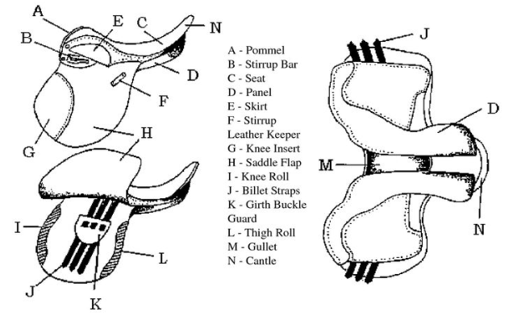

Assessor name: ________________________________________________ Date: ________________
Assessor signature: _____________________________________________
Employee signature: ____________________________________________ Date: ________________

Competent Not Yet Competent

