Competency Check: Grooming horses
Employee name:_________________________________________________ Date:____________
Context: | This Competency Checklist covers the process of grooming a horse and covers the following performance criteria:  - Preparing for grooming  - Groom horses  - Complete grooming process  - Points of the horse  Applicants must have successfully demonstrated the ability to perform the performance criteria in order to be deemed competent to groom horses.
Grooming horses
Task | Performance Criteria | Competent (C) Not Yet Competent (NYC)
1: Preparing for grooming | - Grooming equipment is selected and the use of each tool explained: Brushes, combs, hoof pick etc  - Horse is checked for soundness by:  - Visually looking for lumps, bumps, bites, scratches, lameness etc  - Running GLOVELESS hands over the horses body, under where the saddle and bridle sits and around the girth  - Any obvious signs of injury/ discomfort are reported to a Racing Hearts staff member
2: Groom Horses | - Horse is either held in hand by a second person, or tied up as outlined in “Competence Check – Tie Up”.  - Handler stands in a safe position to the side of the horse, neither directly in front nor behind as the horse can’t see you there and on the same side as the person grooming  - Regular contact is made with the horse by the spare hand.  - Demonstrates correct grooming technique:  - Brushes with the lay of the hair  - Removes dirt and debris from all over the horses body but particularly where any gear comes into contact with the horse i.e. bridle, saddle, girth , boots  - Brushes out mane and forelock  - Stands at the horses’ hip, not directly behind the horse to brush out tail.
3: Complete grooming process | - Correctly demonstrates ability to clean brushes correctly  - Remove hair and dirt from brushes after each use  - Using water and soap  - Using disinfecting agents (With PPE)  - Quick clean by rubbing 2 brushes together and removing dirt build up.  - Returns grooming gear back into labelled containers or places into “dirty” container for cleaning if assessed as too dirty for reuse.
4: Points of the horse | - Indicate to the assessor that you know the points of the horse as depicted in the following illustration:
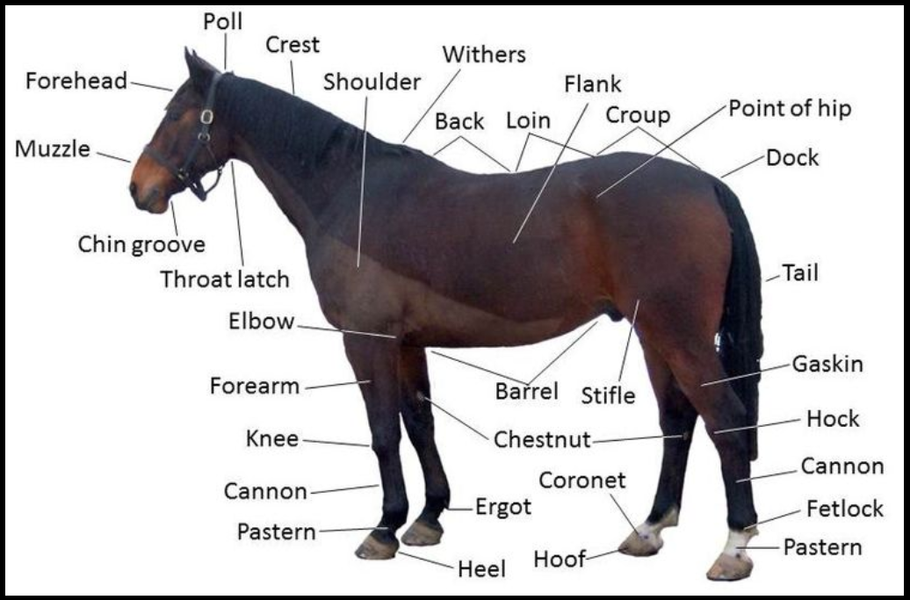
Source - https://en.wikipedia.org/wiki/Equine_anatomy
Assessor name: ________________________________________________ Date: ________________
Assessor signature: _____________________________________________
Employee signature: ____________________________________________ Date: ________________

Competent Not Yet Competent

