Competency Check: Feeding and Watering Horses
Employee name:_________________________________________________ Date:____________
Context: | This Competency Checklist covers the process of feeding a horse and covers the following performance criteria:  - Safety first  - Mixing feeds  - Using the buggy  - Putting out the feeds  - Water  Applicants must demonstrate their ability to meet the required performance criteria to be considered competent in feeding and watering horses.
Task | Performance Criteria | Competent (C) Not Yet Competent (NYC)
1: Safety First | - Horses can be quite competitive and excitable at feed time and may behave in an unpredictable manner.  - Pay attention to horse body language and stay clear of horses are competing with each other for feed buckets.  - Be aware of where each horse is at all times if feeding in a group  - Be aware at all times of how the horses are interacting with each other
2: Mixing Feeds | - All horses at Racing Hearts McIntyre Centre are fed at least one hard feed a day. Each horse has an individual feed which matches the feed of the other horses in the paddock so that if they swap buckets it is not too big a deal.  - All feeds are written up on the white board in the feed room which indicates how many dippers of each food the horses are given.  - Feeds may have additives or supplements added to their feed. This will be noted on the feed board. As a rule, if the supplement/additive is dry/powder, the feed it is going into must be damp or wet so that the powder sticks to the feed and not the bucket so the horses get it.  - Feeds are mixed then stacked in the back of the buggy for distribution, keep in mind which feeds need to be distributed first as you pack the buggy to assist in remembering which feeds are going to which horses  - Only feed horses the outlined mix, horses need a consistent diet and any changes to their diet can only be made by the centre manager  - Do not feed anything to a horse without permission  - If in doubt – ask!
3: Using the Buggy | - The buggy can only be driven by people who have been tested and found to be competent by the centre manager regardless of if they have a current drivers licence or not.  - The buggy must be driven slowly at all times and the driver must be paying due care and attention at all times  - Passengers can ride in the rear of the buggy if the driver of the buggy agrees, but they must sit in the tray and the tail gate must be closed  - Any damage or malfunction of the buggy must be reported as soon as possible to keep the buggy in good order.
4: Putting out the feeds | - The feeds stacked on the rear tray of the buggy are taken down to the paddock and fed out accordingly  - Feed out the buckets quickly so that the horses have less time to fight with each other  - Space the feed buckets at least 3-4horse lengths apart to encourage each horse to stay at its own bucket and reduce competitive behaviour and subsequently injuries  - Where possible, feed the horses by pushing the buckets through the fence in a line along the fence, pushing them into the paddock as far as you can. Be aware that this is not possible in all paddocks, especially those with electric fencing  - In paddocks where the fence is electrified by stand offs (Yellow Gate paddock), take the buckets into the paddock and distribute them away from the fence line.  - If there are horses in the laneway, take the buckets into the paddock to avoid fights over the fence.  - In situations where you have to take the buggy in to the paddock, drive well away from to gate to give more space; observe the horse body language and use caution.  - If in doubt ask for assistance.
Water | - Waters must be checked and refilled in the morning and if necessary, in the afternoon. A 500 kg horse can drink 25-50 litres of water per day under normal conditions. If the weather is hot and humid, if the horse is working hard this amount increases so it is vital that our horses have access to fresh water at all times.  - After feeding out the buckets, all troughs are to be inspected, if the water is green and stale the water must be emptied, the trough scrubbed, and refilled.  - The tool for opening the drain is in the white bucket (metal P shaped) and the broom for scrubbing is in the rear tray of the buggy. This bucket and its contents are not to be removed from the buggy.  - Stay with the water trough while you are filling it as leaving a water tap on can result in large water bills and muddy paddocks. Ensure all taps are in the off position before you move to the next trough.  - Check all troughs on the way back up from feeding up and pick up any empty buckets you find as you go.  - Water troughs in paddocks with windsucking horses need to be coated with crib stop product which will be in the pockets under the dash in the buggy – take care to only put the product on the top edge of the trough and not in the water. Beware also of the electric fence in this paddock. The troughs in the Jenny Craig paddock and Pony paddock fill from the wash bay. In order to use the taps on these troughs, you need to first turn on the wash bay tap on the rear wall of the wash bay, then the tap on the trough.  - Empty feed buckets are left near the hose in front of the tack room for cleaning before re-use
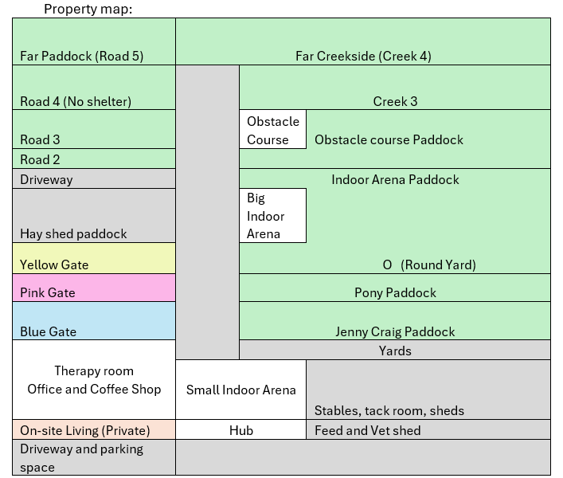
Assessor name: ________________________________________________ Date: ________________
Assessor signature: _____________________________________________
Employee signature: ____________________________________________ Date: ________________

Competent Not Yet Competent

