Competency Check: Horse Welfare
Employee name:_________________________________________________ Date:____________
Context: | This Competency Checklist covers an introduction to horse welfare and covers the following performance criteria:  - Get to know your horses  - Basic Horse Welfare  - Daily Care  - Medications  - Report concerns  Applicants must have successfully demonstrated the ability to perform the performance criteria in order to be deemed competent to understand basic horse welfare.
Task | Performance Criteria | Competent (C) Not Yet Competent (NYC)
1: Get to know your horses | - Horses demonstrate a broad range of emotional and physical behaviours that their handlers need to learn to recognise for the individual horses in your care so that you can recognise and report any changes in behaviour which may indicate illness or welfare issues. Remember, what may be ‘normal’ for one horse may not necessarily be the norm for every horse.  - If you are unsure about the behaviour or a horse, discuss with your coach or an adult staff member.
2: Basic Horse Welfare | - Horse carers need to consider “five domains” to ensure a horses welfare. These domains are:  - Nutrition – enough water and a balanced and varied diet. Access to food for most of the day so they can eat little and often  - Physical Environment – safe and appropriate surroundings  - Health – fit and healthy, illnesses and injuries are treated  - Behavioural Interactions – able to express natural behaviours including exercise, foraging and social interactions. These all lead into a happy ……  - Mental State – see the infographic below from Pony Club Australia.
3: Daily Care | - When handling horses on a daily basis, keep in mind the five domains which a horse needs to have good welfare.  - Fresh water, clean feed containers, access to hay when waiting in yards or on the tie up rail, other horses nearby to keep them company while they are waiting, injuries or illness identified and care given.
4: Medications | - Never administer any medication or treatment to a horse without permission, as incorrect or excessive treatment can delay healing or even harm the horse’s health.  - If a horse is to have any treatment administered by you, ensure you know the exact dose, the method of administration and when the treatment needs to be made. If you are ever in doubt, ask an adult member and or check with centre management. All treatments must be recorded in the diary in the tack room.
5: Report | - Always report any new injuries or concerns, and if in doubt discuss with your coach or adult staff member.
For more information on horse welfare, go to the following links: Pony Club Australia PCA-Horse-Welfare-Policy-V4.pdf and Qld Racing Off The Track program Off-The-Track :: Racing Queensland
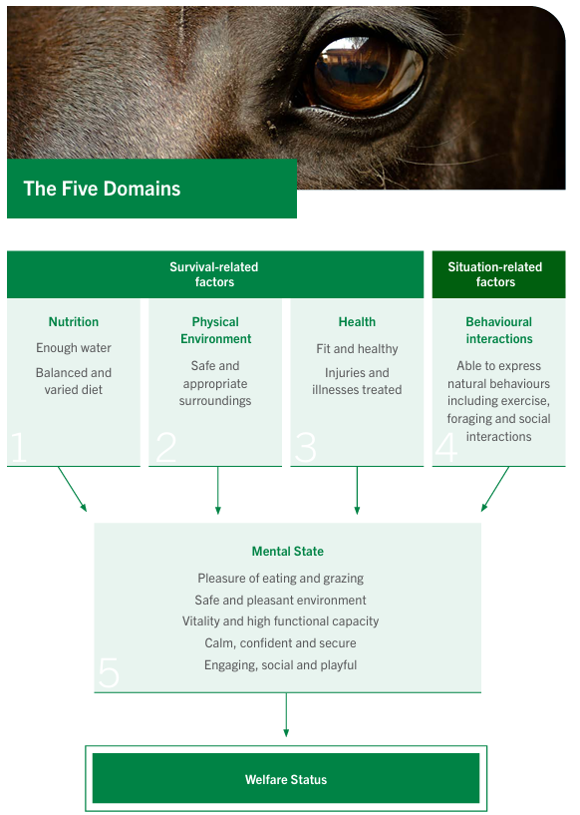
Assessor name: ________________________________________________ Date: ________________
Assessor signature: _____________________________________________
Employee signature: ____________________________________________ Date: ________________

Competent Not Yet Competent

